A

Mini Project Report on
GestureTalk-A real time sign language interpreter

Submitted in partial fulfillment of the requirements for the degree

Third Year Engineering – Computer Science and Engineering-Data Science

by
Sara Rajpurkar | 23107096
Bhumika nikam | 23107009
Rutuja sawant | 23107143
Prajakta bhanushali | 23107057

Under the guidance of
Ms. Swati Parhad

DEPARTMENT OF COMPUTER SCIENCE AND ENGINEERING-DATA SCIENCE
A.P. SHAH INSTITUTE OF TECHNOLOGY
G.B. Road, Kasarvadavali, Thane (W)-400615 UNIVERSITY OF MUMBAI

Academic year: 2025-26

CERTIFICATE

This to certify that the Mini Project report on Sign language interpreter has been submitted by Sara rajpurkar (23107096), Bhumika nikam (23107009), Rutuja sawant (23107143) and Prajakta bhanushali (23107057). who are bonafide students of A. P. Shah Institute of Technology, Thane as a partial fulfillment of the requirement for the degree in Computer Science and Engineering-Data Science, during the academic year 2025-2026 in the satisfactory manner as per the curriculum laid down by University of Mumbai.

Ms. Swati Parhad
Guide

Dr.Pravin Adivarekar Dr. Uttam D. Kolekar
HOD, CSE (Data Science) Principal

External Examiner: Internal Examiner:
1. 1.

Place: A. P. Shah Institute of Technology, Thane

ACKNOWLEDGEMENT

This project would not have come to fruition without the invaluable help of our guide Ms. Swati Parhad expressing gratitude towards our HoD, Dr.Pravin Adivarekar, and the Department of Computer Science Engineering - Data Science for providing us with the opportunity as well as the support required to pursue this project. We would also like to thank our project coordinator Ms. Avani Nair who gave us his valuable suggestions and ideas when we were in need of them. We would also like to thank our peers for their helpful suggestions.

TABLE OF CONTENTS
- Introduction 1
  - Purpose 2
  - Problem Statement 3
  - Objectives 3
  - Scope 5
- Proposed System 6
  - Features and Functionality 6
- Project Outcomes 7
- Software Requirements 8
- Project Design 10
- Project Scheduling 12
- Results 13
- Conclusion 19
References

Chapter 1

Introduction

A Sign Language to Text and Speech Conversion system is a specialized software application designed to bridge the communication gap between the deaf and mute (D&M) community and the general public. American sign language is a predominant sign language. Since the primary disability D&M people face is communication-related and they cannot use spoken languages, their only way to communicate is through sign language.
Communication is the exchange of thoughts and messages through speech, signals, behavior, and visuals. Deaf and mute individuals utilize hand gestures to express their ideas. As the need for inclusive communication grows, relying solely on human interpreters becomes impractical. This is where a computer-vision-based gesture recognition system comes into play, offering a natural interaction between humans and computers without the need for expensive extra devices, thereby reducing costs and optimizing daily interactions.

The system translates known gestures into words using a Convolutional Neural Network (CNN). In addition to generating text, the system utilizes the pyttsx3 library to convert the recognized words into appropriate speech, creating a simple but highly useful simulation of a real-life dialogue. Built using Python, OpenCV, and Keras, the system captures real-time input from a standard webcam, classifying American Sign Language (ASL) gestures and providing seamless, immediate output.

To engineer a technological solution to this barrier, early researchers developed hardware-centric approaches, most notably sensor-based data gloves. These gloves were equipped with flex sensors, accelerometers, and gyroscopes to physically measure the bend of fingers and the trajectory of the hand. While highly accurate, these hardware solutions were inherently flawed for widespread public adoption. They were prohibitively expensive, required constant recalibration, were uncomfortable for prolonged use, and severely restricted the user's natural range of motion.
In addition this project transcends mere text translation by integrating an immediate audio-synthesis pipeline. Using the offline text-to-speech library pyttsx3, the system reads the predicted text strings and vocalizes them instantly. This multimodal output—generating both readable text and audible speech—allows a deaf individual to "speak" to a hearing individual through the computer in real-time, simulating the natural flow of human conversation. By eliminating the need for expensive hardware and human interpreters, this vision-based application represents a significant step forward in building a truly inclusive, digitally empowered society.

In recent years, the exponential advancement of artificial intelligence, specifically in the domains of Computer Vision and Deep Learning, has paved the way for a more organic and non-intrusive approach. Vision-based gesture recognition systems leverage standard optical sensors—such as the integrated webcams found on almost every modern laptop and smartphone—to interpret sign language without any physical encumbrance on the user. By treating gesture recognition as an advanced image classification problem, modern algorithms can visually track a user's hand, extract complex spatial geometries, and translate those visual cues into corresponding linguistic data.

Purpose

The purpose of the Sign Language to Text and Speech Conversion System is to develop an intelligent and efficient communication platform that enables seamless interaction between hearing-impaired individuals and people who are not familiar with sign language. In today’s world, communication plays a vital role in personal, educational, and professional environments; however, deaf and mute individuals often face difficulties in expressing themselves due to the lack of widespread understanding of sign language.
.

    - Real-time Communication:

The system processes gestures instantly using a webcam, allowing real-time conversion into text and speech. This helps maintain a natural flow of communication between users.

    - Automation of gesture Recognition

It automates the process of identifying hand gestures using machine learning techniques, eliminating the need for manual interpretation. This ensures faster and more accurate recognition of gestures.

    - Improved Accessibility

It provides a practical communication tool that can be used in daily life, education, and workplaces. This improves participation and inclusivity for hearing-impaired individuals.

Problem Statement

Hearing-impaired individuals face significant challenges in communicating with people who are not familiar with sign language. Since sign language is not widely understood by the general population, it creates a major communication gap in everyday situations such as education, workplaces, healthcare, and social interactions. This often leads to misunderstandings, limited participation, and difficulty in expressing thoughts effectively.

Additionally, traditional methods such as writing or basic gestures are often slow and inefficient, which further limits effective interaction. Existing technological solutions are either expensive, complex, or require specialized hardware, reducing their accessibility for common users. Therefore, there is a need for a cost-effective, accurate, and real-time system that can automatically recognize sign language gestures and convert them into text and speech, thereby improving communication and promoting inclusivity.

Objectives

The Sign Language to Text and Speech Conversion System is designed to create an effective solution for recognizing hand gestures and converting them into text and speech. The system focuses on enabling smooth and real-time communication using computer vision and machine learning techniques. It aims to ensure accurate gesture detection while maintaining efficiency and speed. The design also emphasizes ease of use so that users can interact with the system without difficulty. Overall, the system contributes towards improving communication accessibility for hearing-impaired individuals.
- Real-time Capture: To capture and process live hand gestures using a webcam in real time. This ensures smooth and continuous interaction by minimizing delay and enabling instant gesture recognition.

- Predictive support: To suggest similar words for the words predicted by the system. This helps improve accuracy and assists users in selecting the correct output more efficiently.

- Text conversion: To convert recognized sign language gestures into readable text. This allows easy understanding of gestures for users who are not familiar with sign language.

- Speech conversion: To convert the recognized sign language text into audible speech. This enhances communication by providing voice output for better interaction in real-world situations.

Scope

The scope of the Sign Language to Text and Speech Conversion System focuses on developing a real-time solution that enables effective communication between hearing-impaired individuals and others. The system is designed to recognize hand gestures and convert them into text and speech using machine learning and computer vision techniques. It aims to provide a practical and accessible tool that can be used in everyday situations such as education, workplaces, and public interactions. The system ensures ease of use while maintaining accuracy and efficiency in gesture recognition.

    - Real-Time Gesture Recognition:

The system is capable of capturing and recognizing hand gestures in real time using a webcam. This ensures smooth and continuous communication without delays, making it suitable for everyday use..

    - Conversion of Gestures into Text and Speech:

The recognized gestures are converted into readable text and further into speech output. This allows users to communicate effectively with people who do not understand sign language.

    - User-Friendly and Accessible System:

The system is designed to be simple and easy to use, requiring only a webcam and basic setup. This makes it accessible to a wide range of users without the need for specialized hardware.

Chapter 2

Proposed System

The proposed Sign Language to Text and Speech Conversion System is designed as a real-time communication solution that helps bridge the gap between hearing-impaired individuals and those who do not understand sign language. The system captures hand gestures using a webcam and processes them using computer vision techniques to identify the gestures accurately. It uses advanced machine learning algorithms, particularly Convolutional Neural Networks (CNN), to classify gestures into corresponding alphabets or words. MediaPipe is integrated for effective hand landmark detection, which improves accuracy even in different backgrounds and lighting conditions. The recognized gestures are then converted into text and further into speech using a text-to-speech module.

Features and Functionality

The features and functionalities of the proposed Sign Language Interpreter provide an efficient and real-time communication solution by capturing hand gestures using a webcam and processing them through image processing techniques. The system performs preprocessing steps such as grayscale conversion, noise reduction, and thresholding to enhance the quality of the captured image. It utilizes MediaPipe for accurate hand landmark detection, which helps in identifying finger positions and gesture patterns effectively. A trained Convolutional Neural Network (CNN) model is used to classify the gestures into corresponding outputs with high accuracy. The recognized gestures are then converted into readable text and further into speech using a text-to-speech module, enabling seamless communication between users. The system is designed to be user-friendly, cost-effective, and accessible, requiring no specialized hardware while maintaining efficient real-time performance.

The system includes these key features:

    - Real-time Gesture Recognition: Detects and processes hand gestures instantly
Using a webcam for smooth communication.

    - Text and speech conversion: Converts recognized gestures into readable text and audible speech output.

    - Accurate Gesture Detection using CNN and Mediapipe: The system uses machine
Learning techniques along with landmark detection to achieve high accuracy. .

Chapter 3

Project Outcomes

The Sign Language to Text and Speech Conversion System successfully provides a real-time solution for communication between hearing-impaired individuals and others. The system is capable of accurately detecting hand gestures using a webcam and processing them through computer vision and machine learning techniques. This enables users to communicate their thoughts effectively without relying on manual interpretation.
The integration of MediaPipe and Convolutional Neural Network (CNN) has significantly improved the accuracy and reliability of gesture recognition. The system performs well under normal lighting conditions and is able to recognize gestures efficiently with minimal delay. The use of a text-to-speech module further enhances the communication process by converting text into audible output.
Overall, the system demonstrates a practical and cost-effective approach to solving real-world communication problems. It eliminates the need for specialized hardware and provides an easy-to-use interface, making it accessible to a wide range of users. The project highlights the potential of artificial intelligence in improving accessibility and inclusivity:

    - Accurate Gesture Recognition: Managing customer and inventory data efficiently reduction in manual processes, leading to time savings and lower error rates.

    - Real-Time Communication: It provides instant conversion of gestures into text and speech, allowing smooth and continuous interaction. This helps maintain a natural flow of communication between users.

    - Improved Accessibility: The system enables hearing-impaired individuals to communicate more easily in daily life situations. It reduces dependancy

On interpreters and promotes independence.It allows users to participate more actively.

Chapter 4

Software Requirements

The Sign Language to Text and Speech Conversion System requires a set of software tools and libraries to perform gesture recognition, processing, and output generation efficiently. These technologies work together to ensure smooth functioning, accuracy, and real-time performance. The software requirements are detailed as follows:

Frontend:

  - Python: The primary programming language used for developing the user interface. Python is chosen for its platform independence, strong object-oriented features, and extensive libraries that facilitate the development of a responsive and interactive user experience.

  - Visual Studio (VsCode): VS Code is a powerful, efficient, and versatile IDE that enhances Python development, making it a perfect choice for a smooth workflow. VS Code, being lightweight, cross-platform, and highly extensible, enhances productivity with integrated debugging and Git support. It allows seamless database management, real-time previews, and smooth execution of Python script.

  - OpenCV: OpenCV is used for capturing real-time video input from the webcam and performing image processing operations

  - Mediapipe: MediaPipe is used for detecting hand landmarks and tracking finger movements accurately.

Backend:

  - CNN: CNN is used as the core machine learning model to classify hand gestures based on patterns and features. It helps in achieving high accuracy by learning from the training dataset.
  - TensorFlow/Keras: These libraries are used to build, train, and manage the CNN model efficiently. They provide powerful tools for deep learning and help in optimizing model performance

  - Pyttsx3: This library is used for converting the recognized text into speech output. It enables the system to provide audio output for better

Chapter 5

Project Design

The design of the Sign Language to Text and Speech Conversion System is based on a structured approach that integrates computer vision and machine learning techniques to achieve accurate and real-time gesture recognition. The system begins with capturing hand gestures through a webcam, which acts as the primary input device. The captured video frames are then processed using image processing techniques such as grayscale conversion, noise reduction, and thresholding to improve image quality and remove unnecessary background details. After preprocessing, MediaPipe is used to detect hand landmarks and track finger movements precisely, which helps in identifying the structure and position of the hand. These extracted features are then passed to a trained Convolutional Neural Network (CNN) model, which analyzes the patterns and classifies the gesture into a corresponding output. Once the gesture is recognized, the system converts it into readable text and further processes it using a text-to-speech module to generate audio output.

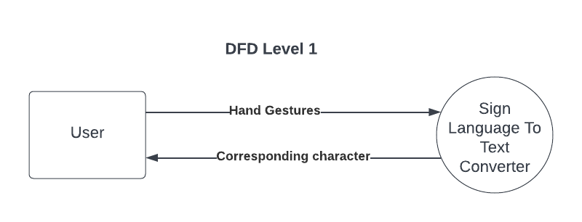

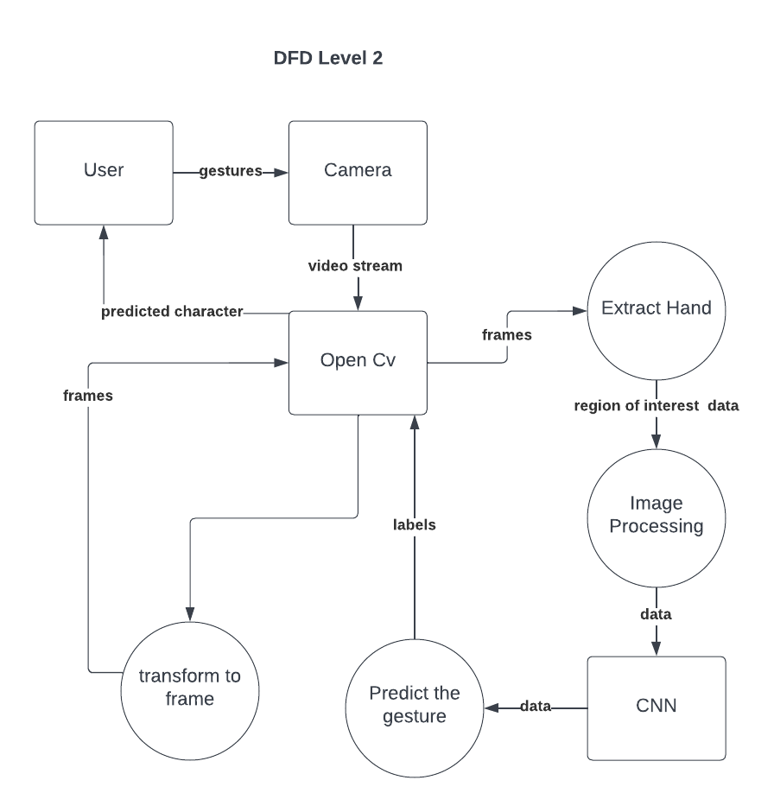

Fig 5.1:DFD diagram

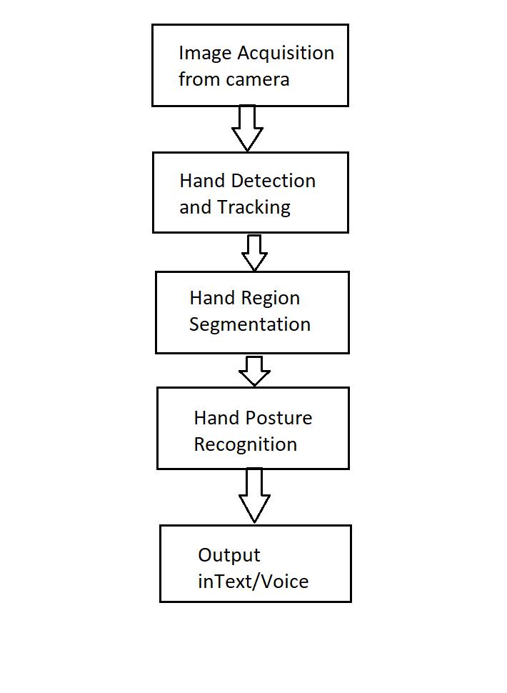

Fig.5.2: system flow diagram

This flow diagram illustrates the working pipeline of a sign language interpreter system. It begins with capturing images from a camera, followed by hand detection, tracking, and segmentation to isolate the hand region. Finally, the system recognizes hand gestures and converts them into text or voice output for communication

Fig 5.3: System Architecture

This diagram illustrates the application's graphical user interface during active operation. It features a live video feed window where the user performs sign language gestures for real-time camera processing and landmark detection..

Adjacent to the video feed, the interface instantly displays the translated alphabetical characters and aggregated words. This dynamic text output ensures clear, continuous, and seamless visual communication for the user.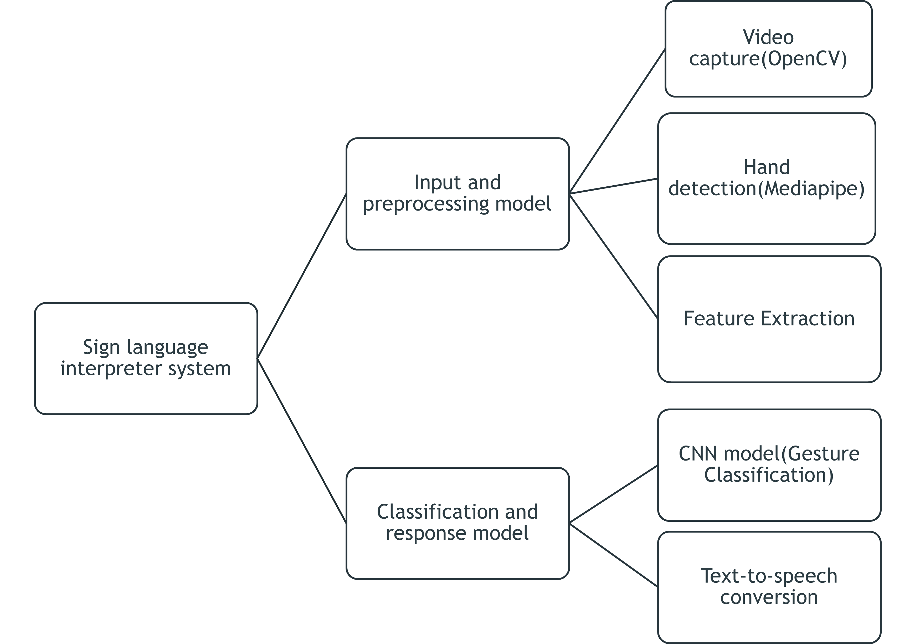

System Overview(user Interaction):
The Sign Language Interpreter system captures real-time hand gestures using a webcam. The input is processed to detect the hand and remove background noise. Important features like hand landmarks are extracted for better understanding of gestures. These features are then used to recognize the gesture accurately. Finally, the system displays the output in the form of text and speech.

System Architecture(Core Processing):
The system architecture consists of multiple stages including input, processing, and output. The webcam captures live video, and MediaPipe detects and extracts hand landmarks. These features are passed to a CNN model for gesture classification. The predicted gesture is converted into text and further into speech using a text-to-speech module. This ensures smooth and real-time communication.

Chapter 6

Project Scheduling

Project scheduling is the process of defining and organizing the tasks, timelines, and resources needed to complete a project. It involves breaking down the project into smaller, manageable tasks, assigning durations and deadlines, and determining dependencies between tasks. A well-structured schedule helps ensure that the project stays on track, meets its deadlines, and allocates resources efficiently. Project scheduling is essential for monitoring progress, identifying potential delays, and ensuring timely project delivery. It is typically visualized using tools like Gantt charts or timelines to provide a clear roadmap for the project's completion.

Conception and Initiation, Project Design and Implementation. Each phase includes various tasks, color coded for distinction, and spans over specific time periods (weeks). Task descriptions, deadlines, and responsibilities are listed, showing a clear project schedule, with progress and dependencies marked visually through bars of different colors. The chart is designed to help track the milestones and deliverables over time, facilitating project management and monitoring.

Figure 6.1: Gantt chart

Chapter 7

Results

The Sign Language to Text and Speech Conversion System was successfully implemented and tested for real-time gesture recognition. The system accurately detects hand gestures using a webcam and processes them using machine learning techniques. The recognized gestures are effectively converted into text and further into speech output, ensuring smooth communication. The system performs well under normal lighting conditions and provides reliable results with minimal delay. Overall, the implementation demonstrates an efficient and practical solution for improving communication accessibility.

.

Figure 7.1:

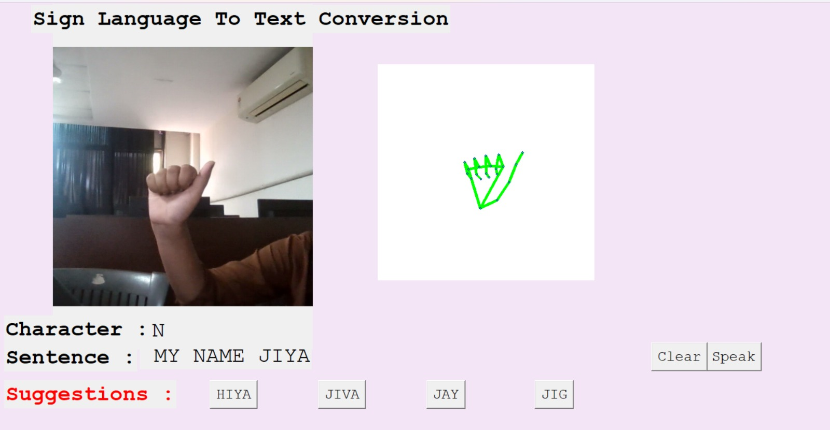

Chapter 8

Conclusion

The Sign Language to Text and Speech Conversion System successfully demonstrates an effective solution for bridging the communication gap between hearing-impaired individuals and people who are not familiar with sign language. The system provides a user-friendly and cost-effective approach, as it requires only a webcam and does not depend on specialized hardware. The project highlights the practical application of artificial intelligence in solving real-world problems and promoting inclusivity. Although the system currently focuses on basic gesture recognition, it has the potential to be expanded for sentence-level translation and multi-language support in the future. Overall, the project achieves its objectives and proves to be an efficient, scalable, and impactful solution for enhancing communication for hearing-impaired individuals.

References

- IJSRST . Sign language Detection and recognition Using Mediapipe and deep
Learning algorithm. (2024).
https://ijsrst.com/index.php/home/article/view/IJSRST5241122

2. IndJST. SignSpeak: Indian Sign Language Recognition with ML Precision. (2025).
https://indjst.org/articles/signspeak-indian-sign-language-recognition-with-ml-precise

- Ashwin S., Srikanth N., Reddy P. Real-Time Hand Gesture Recognition System Using
Deep CNN. (2023).
https://www.ijraset.com/research-paper/sign-language-gesture-detection-using-cnn

